AI Content Summarizer with RAG foundation

Stage-1:
Text given:
C:\Sai Teja Folder\Youtube - Become Genius\Intro.txt
Result of summarizer (Settings - Summary size: Short, Tone: Neutral):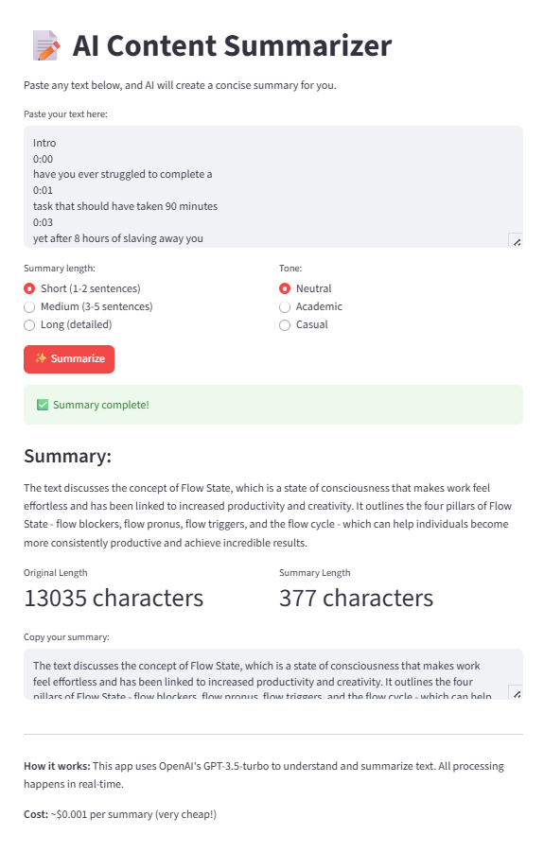

Result of summarizer (Settings - Summary size: Short, Tone: Academic):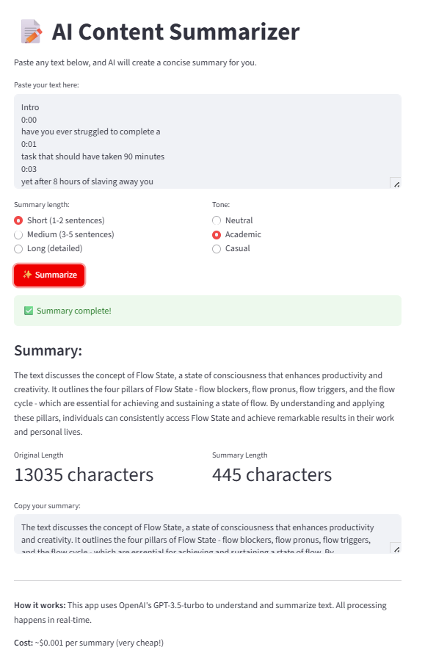

Result of summarizer (Settings - Summary size: Short, Tone: Casual):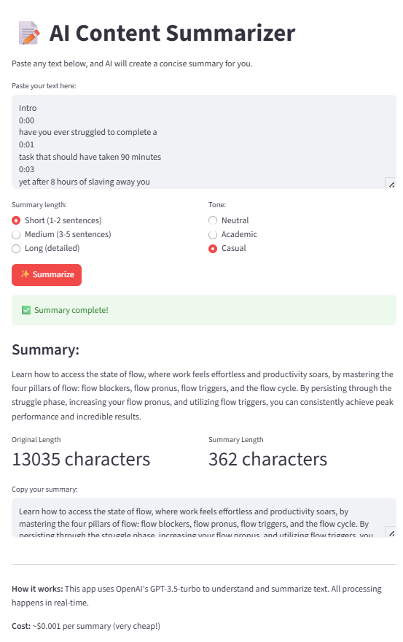
Result of summarizer (Settings - Summary size: Medium, Tone: Neutral):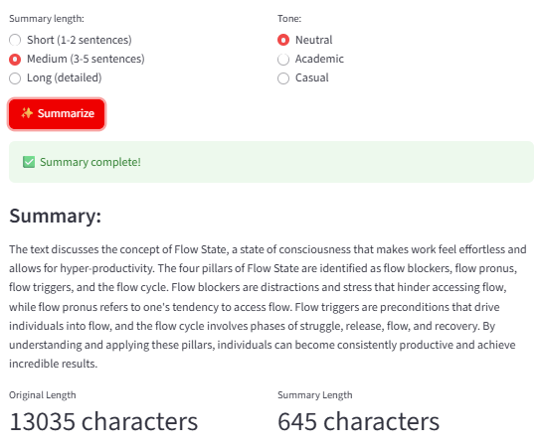
Result of summarizer (Settings - Summary size: Medium, Tone: Academic):
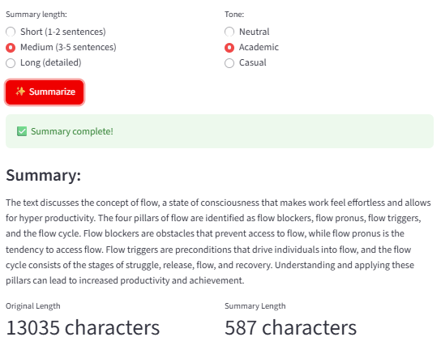

Result of summarizer (Settings - Summary size: Medium, Tone: Casual):
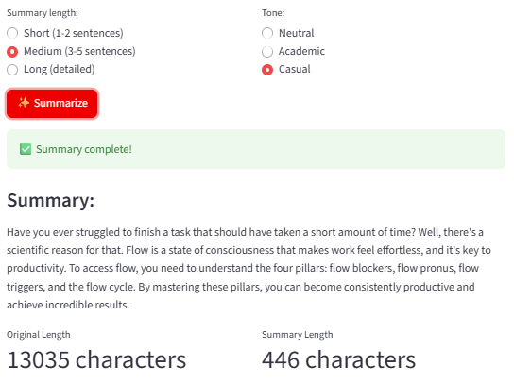

Result of summarizer (Settings - Summary size: Long, Tone: Neutral):
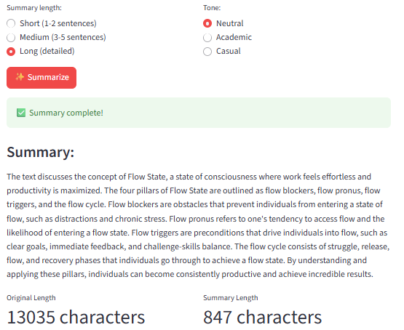
Result of summarizer (Settings - Summary size: Long, Tone: Academic):
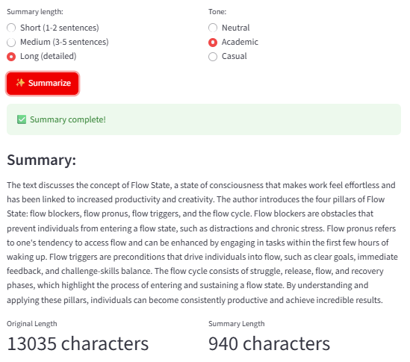
Result of summarizer (Settings - Summary size: Long, Tone: Casual):
